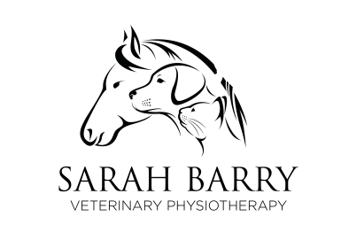
SARAH BARRY VETERINARY PHYSIOTHERAPY
SECTION A
Client Name:
Address:

Contact Number:
Contact Email:
I hereby confirm that the below detailed patient has had veterinary approval for physiotherapy treatement. I consent to Sarah Barry Veterinary Physiotherapy contacting my veterinarian in order to discuss the below mentioned patient, if required, and provide veterinarian with reports of these physiotherapy seessions. I consent to the terms and conditions of treatment
Signed: Date:

SECTION B
Horse Name:
Age: Breed:
Gender:
Is your horse insured:

Name of Insurance Company/Policy Number:

Current medication:
Date of last vaccinatons:
Reason for appointment:

SECTION C
Veterinary Clinic Name:

Clinic Address:

Veterinary Surgeon Name:
Clinic Email Address:
Brief Medical History/reason for referral:

Veterinary Surgeons Declaration:
I can confirm that the above mentioned patient is healthy and suitable for physiotherapy assessment and treatment Signed:___________________Print Name: ________________________________

If you would like to discuss this case, or if you have any questions, please do not hesitate to contact me on 0862547238 or email: sbvetphysio@gmail.com
https://m.facebook.com/Sarah-Barry-Veterinary-Physiotherapy sbvetphysio@gmail.com sbveterinaryphysiotherapy_

